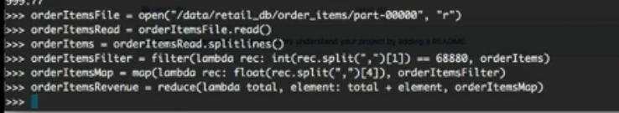

Steps:-

1. Open the file and then read the file.
2. Convert it into list via splitlines function.
3. Then just perform list operations on it via filter.
4. Then map the o/p of filtered o/p after applying transformations on it.
5. Then reduce the o/p and give the final o/p.